**Automatic snapshot deletion using AWS Lambda**

* ***Conditions to be applied for snapshot deletion.***
* **Running and Stopped state Instances**
  1. **Retain last 30days snapshots.**

**2. Snapshots with specific tags shouldn’t be deleted.**

* **Terminated state instances**

**1. Retain latest snapshots and delete remaining.**

**2. Snapshots with specific tags shouldn’t be deleted.**

Step1: - **Create EC2 Instance**

### **Sign into the AWS Management Console:**

Log in to your AWS account.

### **Navigate to the EC2 Dashboard:**

In the AWS Management Console, find and select the "EC2" service.

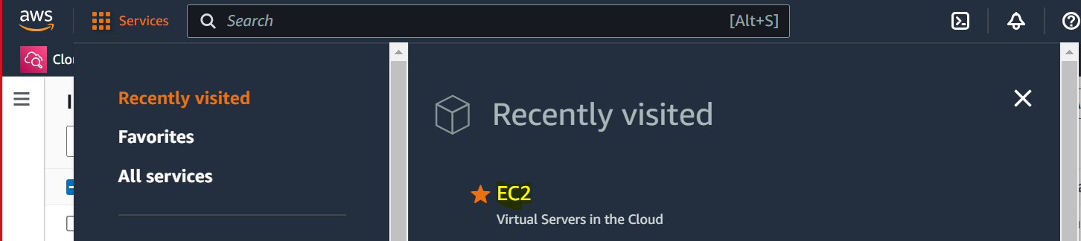

### **Launch Instance:**

Click on the "Instances" option on the left sidebar and then click the "Launch Instance" button.

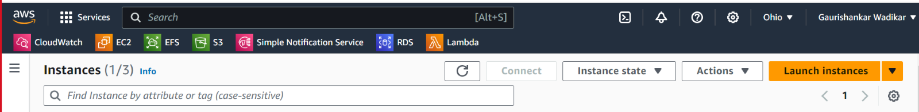

### **Choose an Amazon Machine Image (AMI):**

* Select an AMI that best suits your needs (Amazon Linux, Ubuntu, Windows Server, etc.).

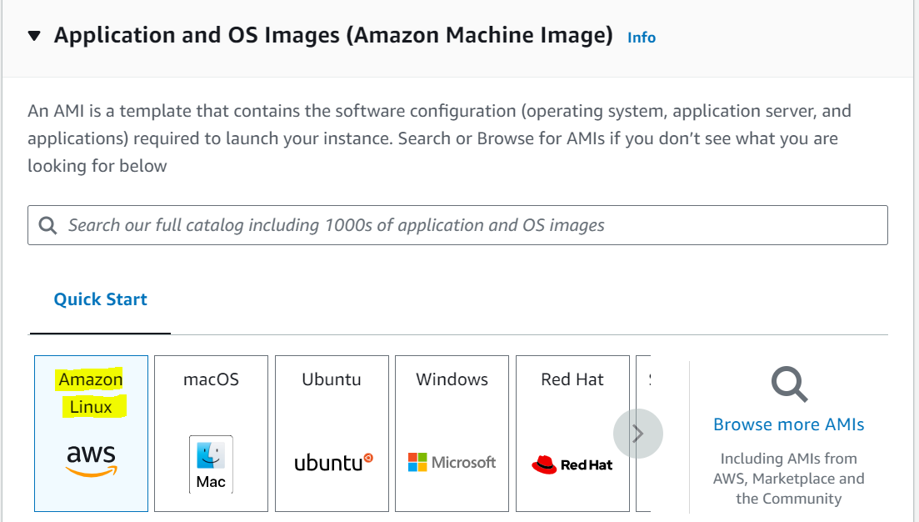

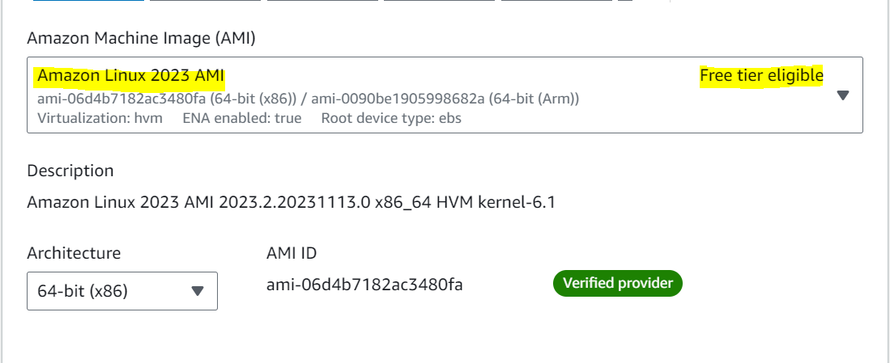

### **Choose an Instance Type:**

* Select the instance type based on your workload requirements (e.g., t2.micro, t3.medium, etc.). Instance types vary in terms of CPU, memory, storage, and networking capacity.

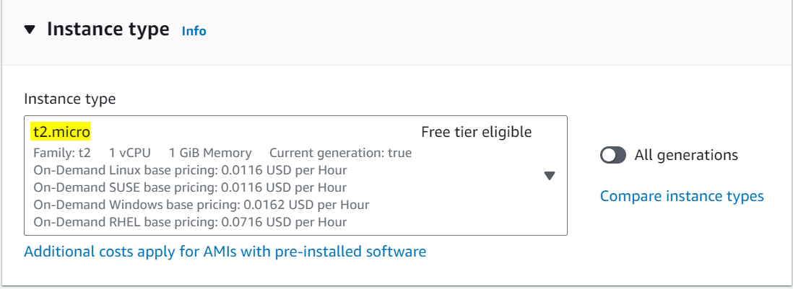

### **Key Pair:**

* Select an existing key pair or create a new one. This key pair will be used to SSH/RDP into your instance securely.

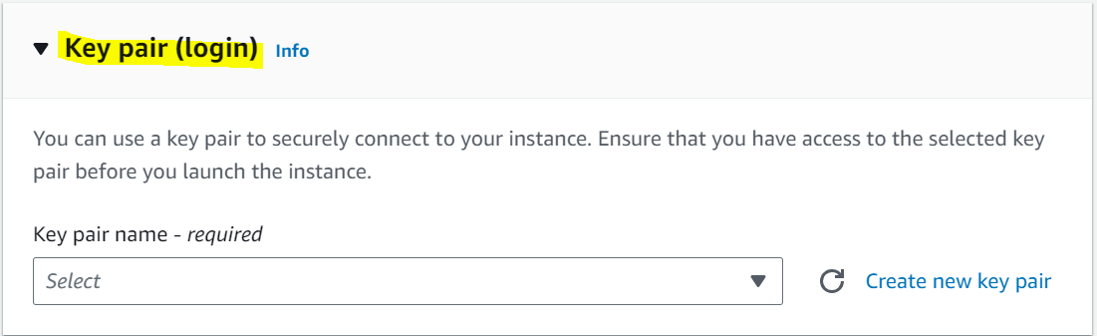

### **Configure Instance:**

* Configure instance details like the number of instances you want to launch, network settings (VPC, subnet), IAM role, etc.

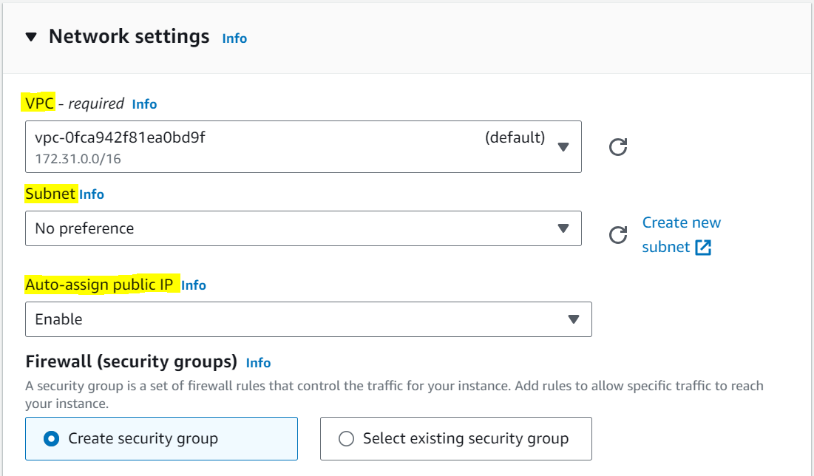

### **Add Storage:**

* Define the storage requirements for your instance. You can add or modify the default storage settings (EBS volumes) based on your needs.

### **Configure Security Group:**

* Create a new security group or choose an existing one. Security groups act as virtual firewalls controlling inbound and outbound traffic to your instance.
* 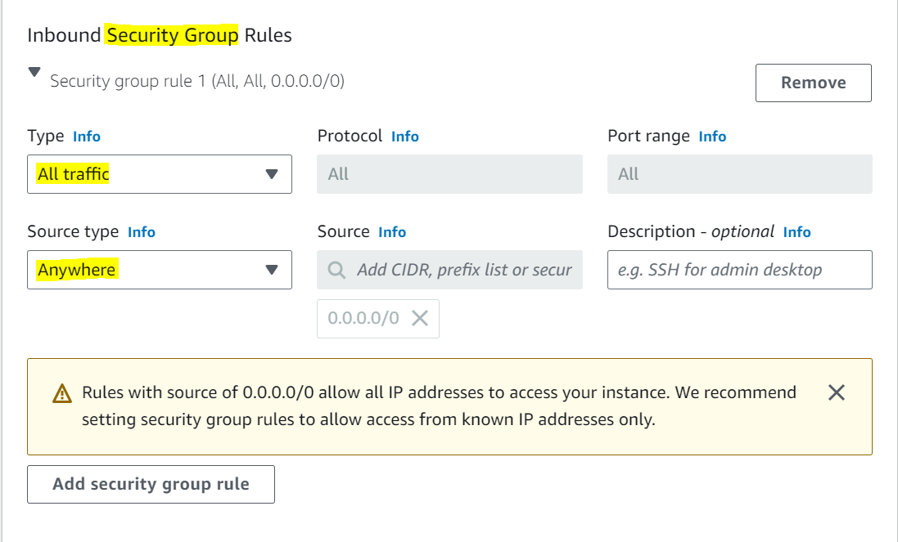

### **Review and Launch:**

* Review the configuration details of your instance.
* You can modify any settings at this stage if needed.

### **Launch Instance:**

* Click the "Launch" button.
* AWS will prompt you to select or create a key pair if you haven't already. This key pair will be used for securely accessing your instance.



### **View Instances:**

* After launching, go back to the EC2 dashboard and click on "Instances" to view the status of your newly created instance.

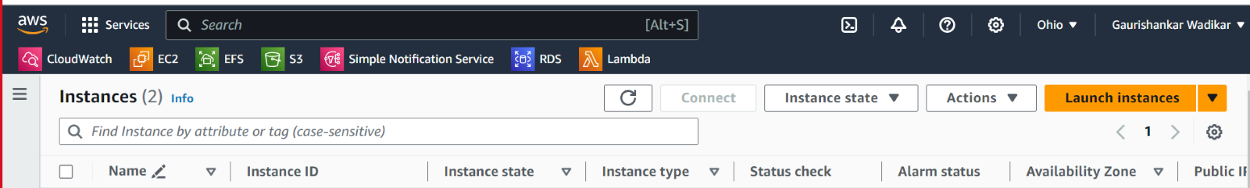

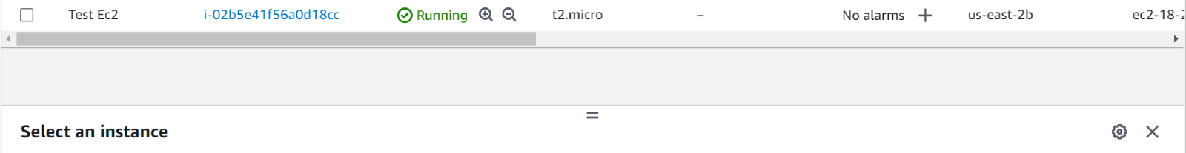

**Steps2: - Create IAM Policies and Rules**

1. **Create Policy: -**

1.Open the AWS Management Console and navigate to the IAM dashboard.

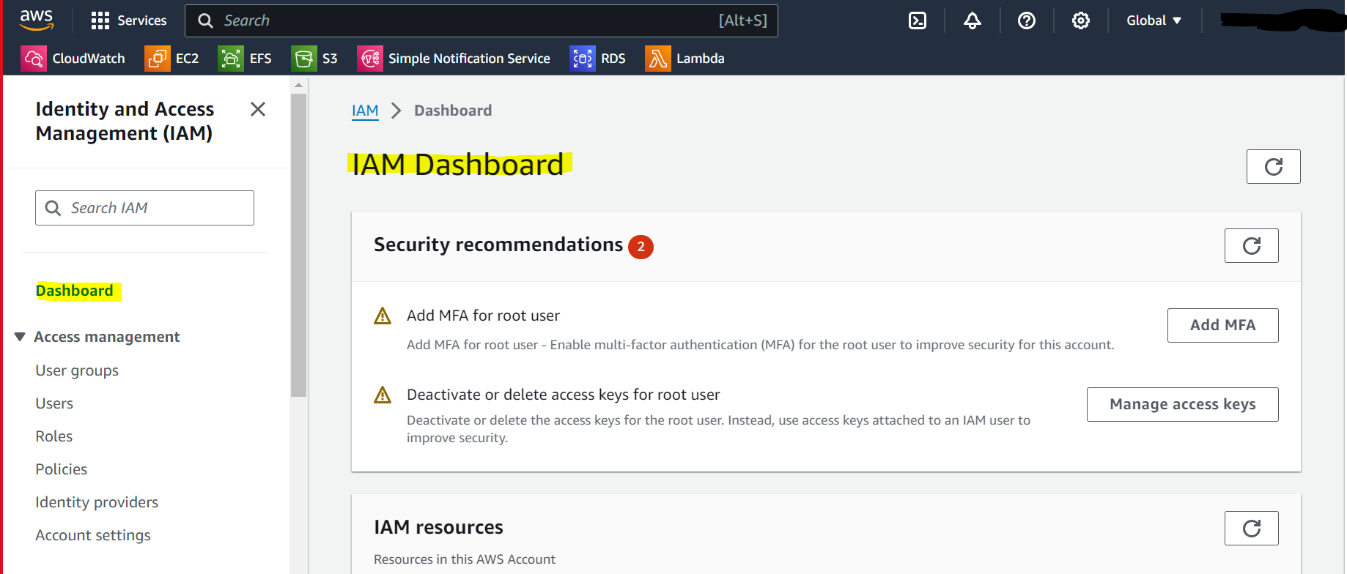

1. In the left navigation pane, choose "Policies" and then click on the "Create policy" button.

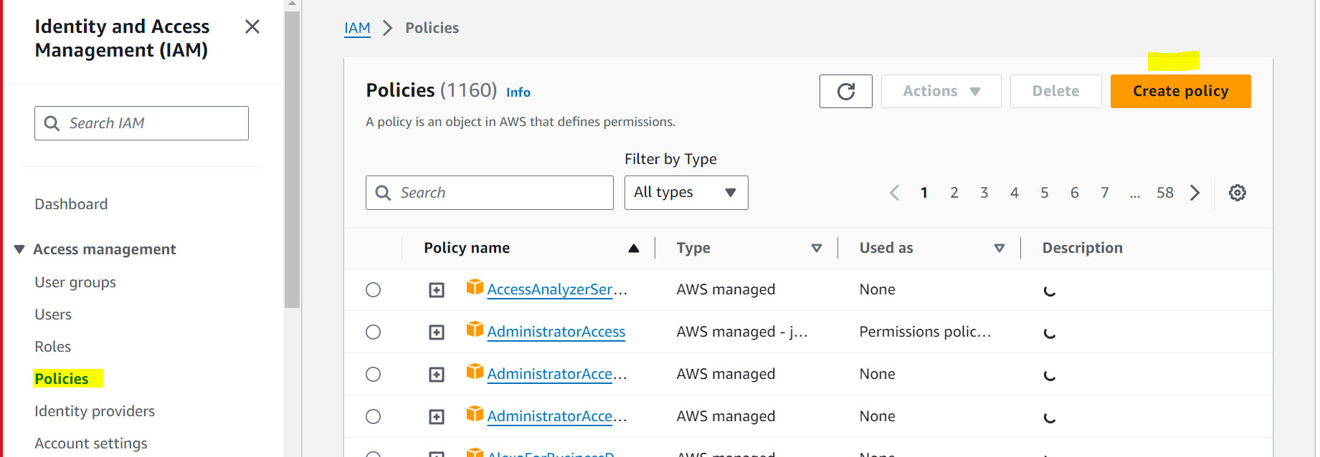

3.Choose the "Visual editor" tab.

* + Click on the "Service" field, search for and select "EC2."
  + In the "Actions" section, expand "Read" and select "DescribeSnapshots" and "DescribeVolumes."
  + In the "Actions" section, expand "Write" and select "DeleteSnapshot."

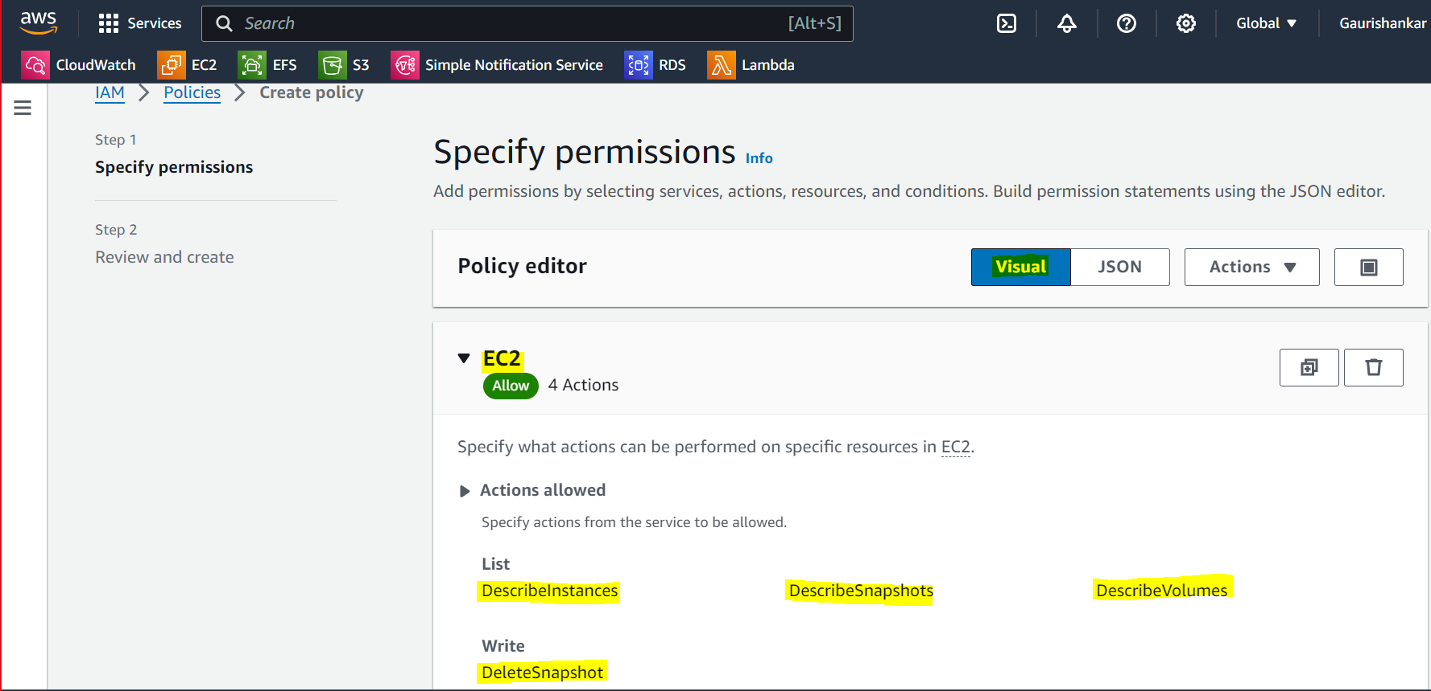

1. In the "Resources" section, click on the "Add ARN" button.

For each action, configure the resource ARN. You can use * for all resources or specify the ARNs of the specific resources you want to allow.  
 Example ARNs:

* + For DescribeSnapshots,DescribeInstances and DescribeVolumes: `arn:aws:ec2:region:account-id:*
  + For DeleteSnapshot: arn:aws:ec2:region:account-id:snapshot/snapshot-id

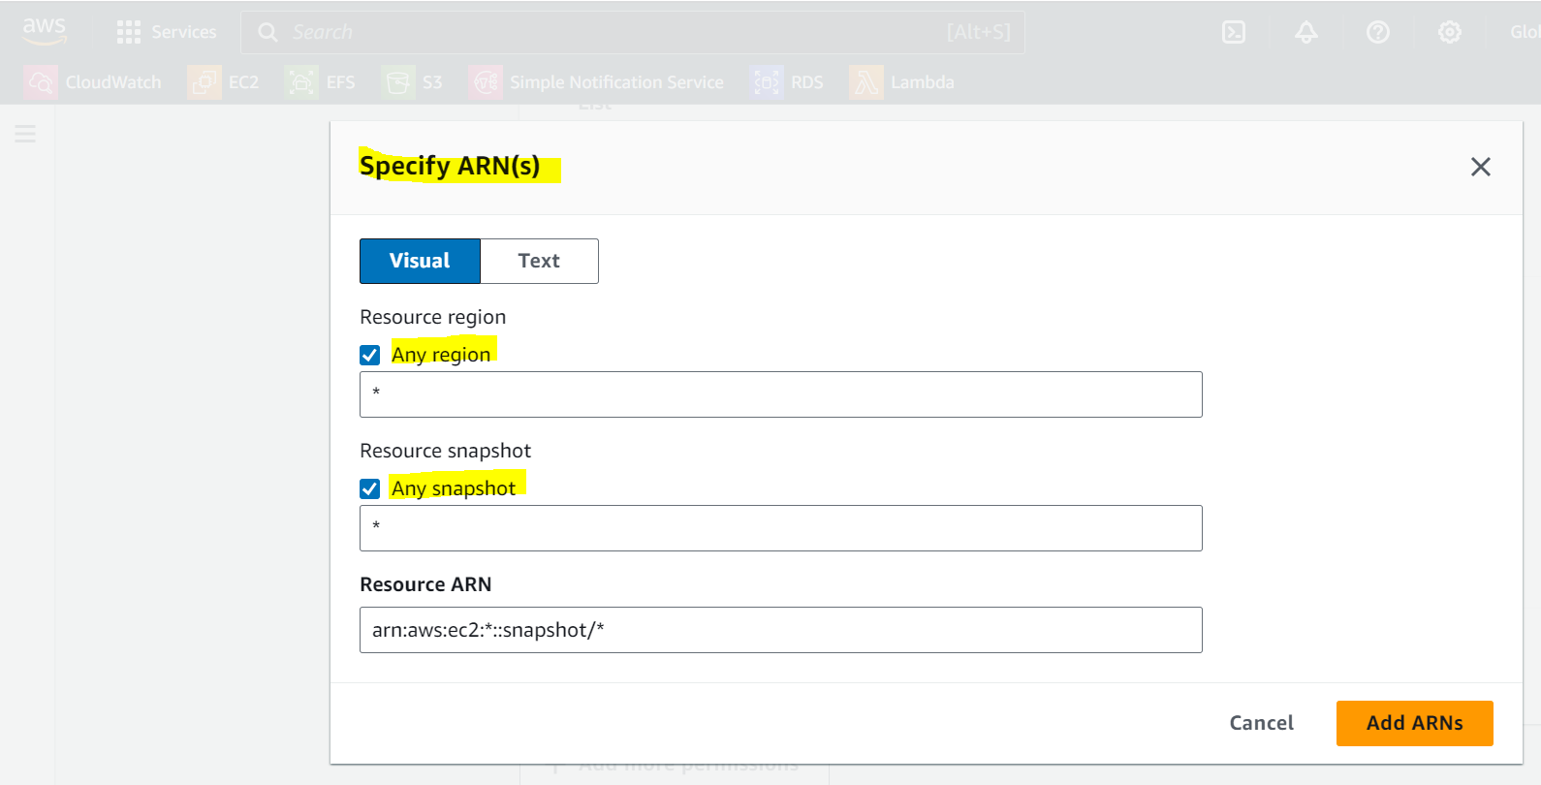

1. Click on the "Review policy" button.
   * Enter a name and description for the policy, and then click "Create policy."

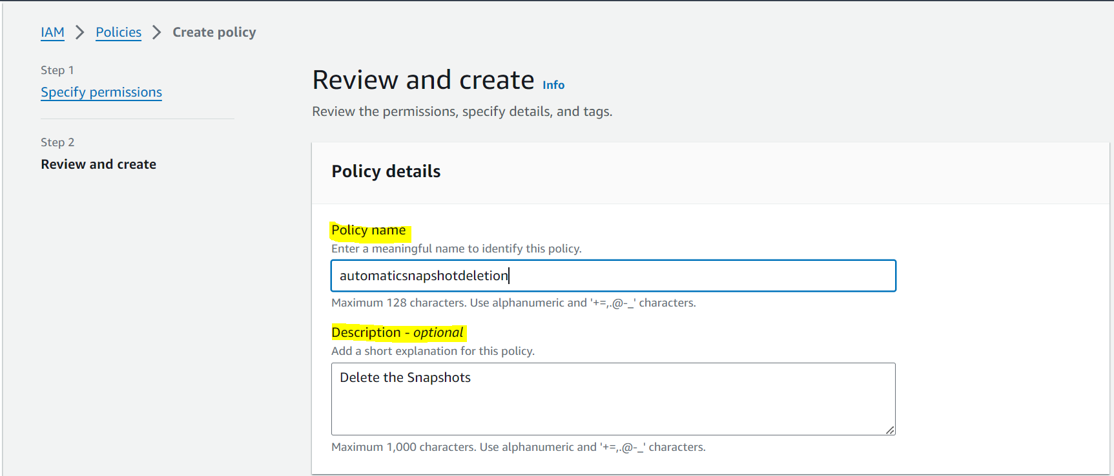



Once our policy has been created, on the left-hand side click on “**Roles**” and then click on the orange button title “***Create roles***”.

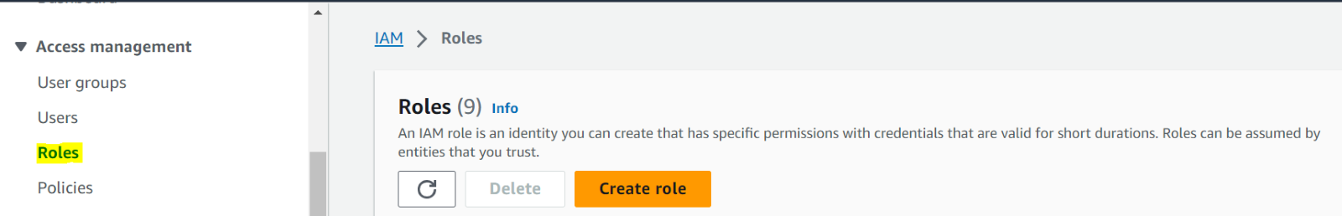

Select the “**AWS Service**” for “**Trusted entity type**” and “**Lambda**” for “**Use case**”, then click on “**next**”.

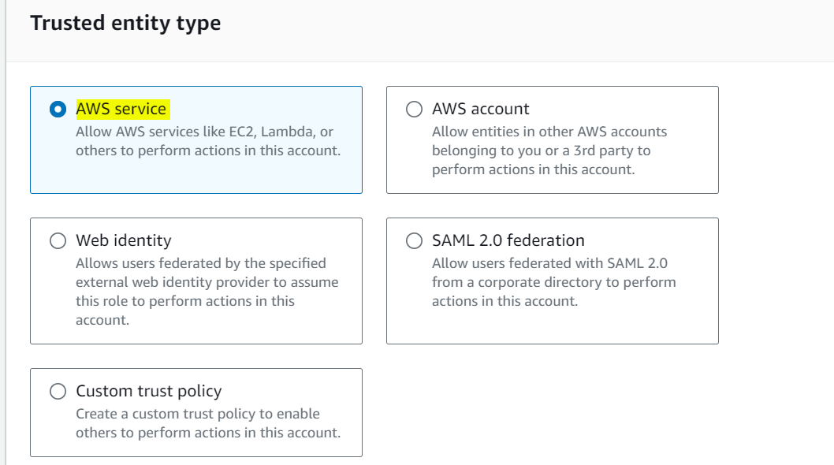

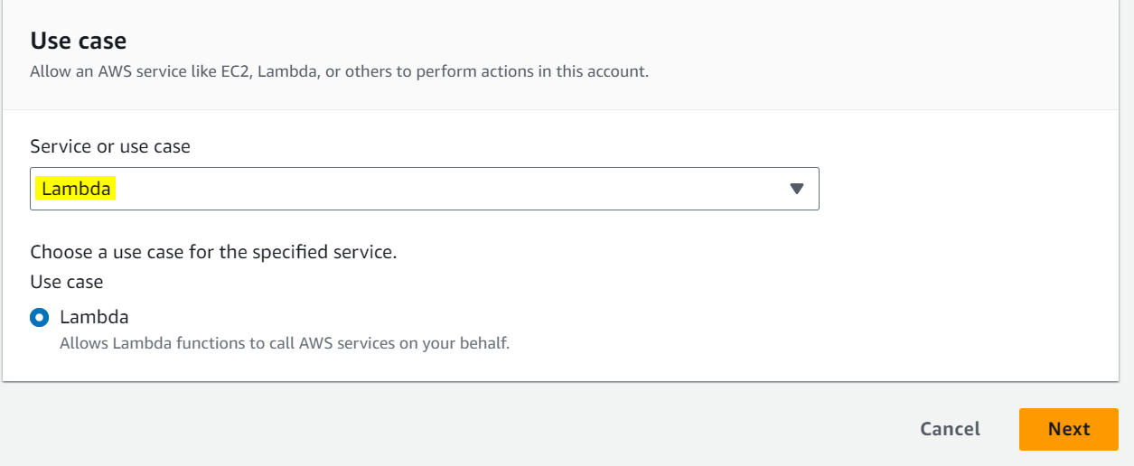

search and select the **policy** created in the steps above then click next.

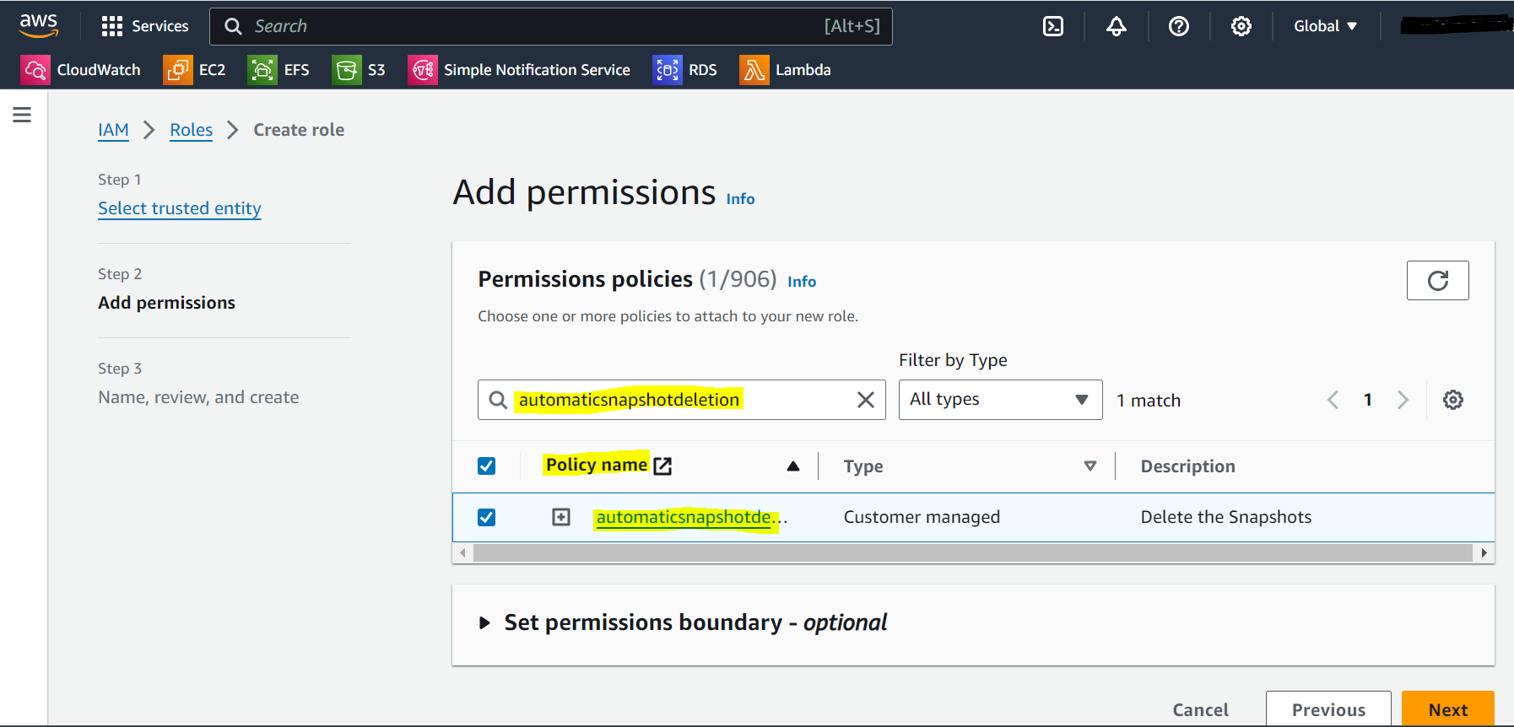

create a name and click on “**Create role**”.

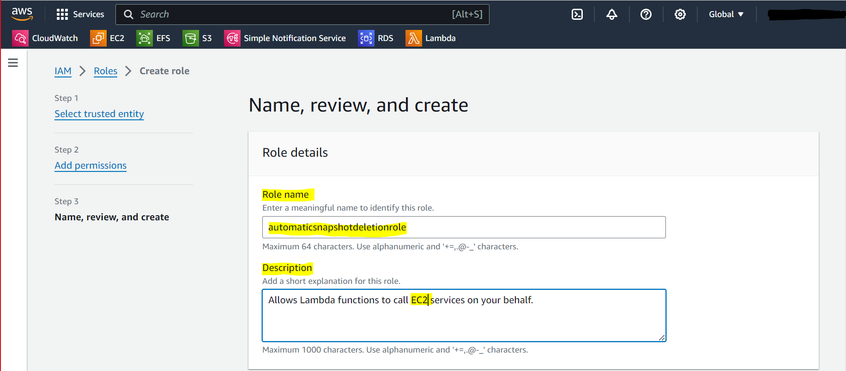



*Step 3:-* **Lambda Functions Creation**

Once the Lambda dashboard is displayed, on the right-hand side click on the orange button title “***Create functions***”.

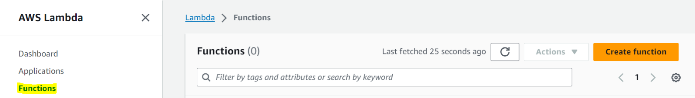

Create a name for our function.

Select **“Python 3.11”** for our runtime.

Select the role we created earlier under the **“Change default execution role”** option.

Then click on “**Create functions**” for **stop** running ec2 Instance

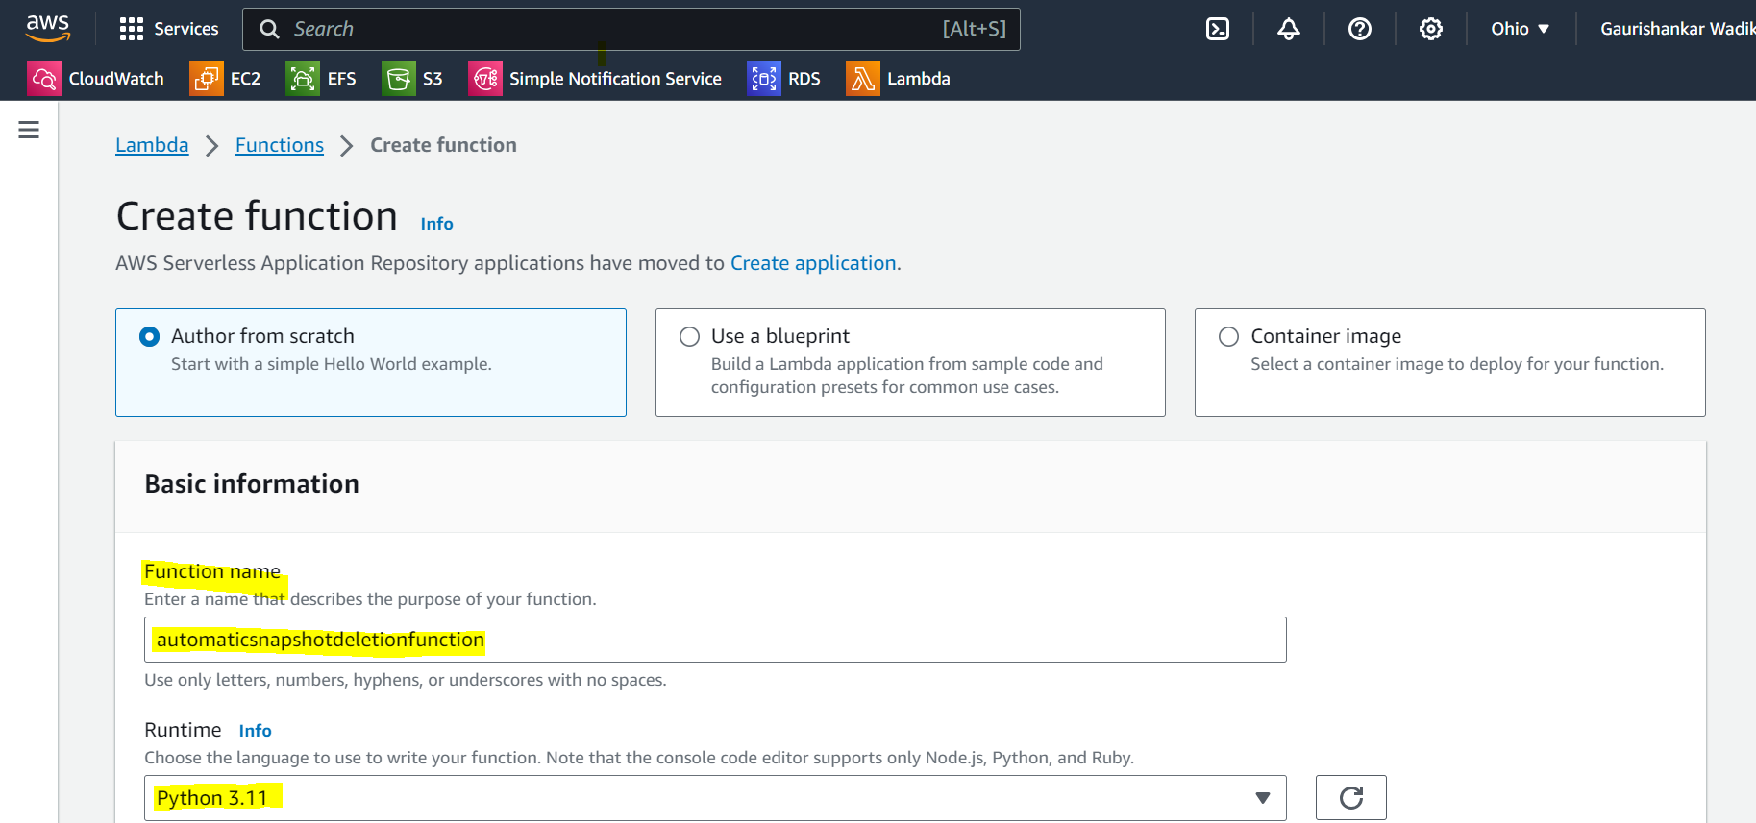

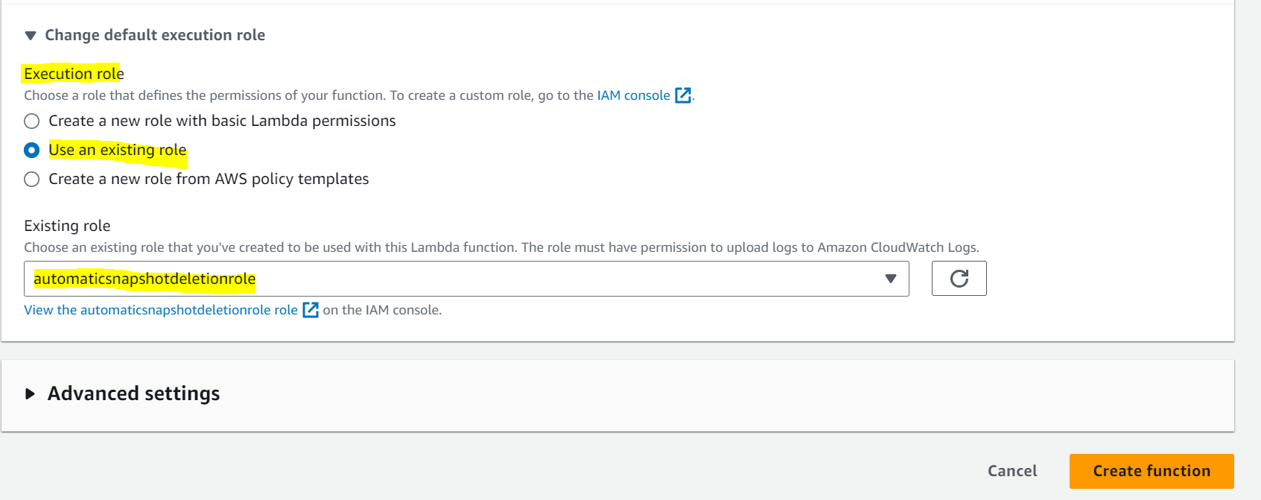

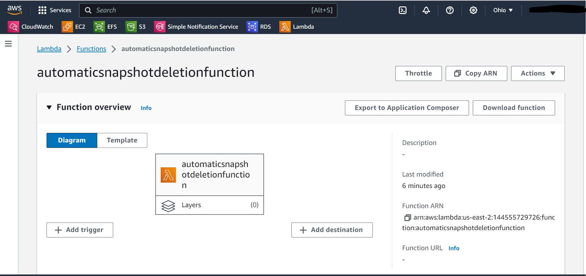

* After creating Lambda function, we can add the required code as per your requirement.

